**CA 3: Experiential Learning**

**Group Members:**

|  |  |  |  |
| --- | --- | --- | --- |
| Sr. No. | PRN | Name of Student | Mail id |
| 1 | 23070122135 | Mayank Hete | mayank.hete.btech2023@sitpune.edu.in |
| 2 | 23070122144 | Sreehari Nair | sreehari.nair.btech2023@sitpune.edu.in |
| 3 | 23070122161 | Parth Damle | parth.damle.btech2023@sitpune.edu.in |
| 4 | 23070122166 | Pratik Lakra | pratik.lakra.btech2023@sitpune.edu.in |

**Problem Statement:**

Users often struggle to manage passwords for multiple online services, leading to poor password practices. A need exists for a user-friendly, local password manager that provides essential password management operations with potential for further enhancements.

**Brief Explanation:**

The Password Manager Project developed in C++ serves as an efficient tool for securely managing user credentials associated with various online platforms. It addresses the growing challenge of password management in an increasingly digital world, where individuals often juggle multiple accounts and passwords.

**Key Features:**

* **CRUD Functionality:** Users can create new passwords, read stored passwords by searching through them, update existing passwords, and delete passwords no longer needed.
* **Persistent Storage:** The application leverages file handling techniques to save passwords in a CSV file, allowing for data persistence across sessions.
* **Object-Oriented Design:** It utilizes principles of object-oriented programming (OOP), such as inheritance and polymorphism. The Password class serves as a base for derived classes *WebsitePassword* and ‘*AppPassword’*, encapsulating the functionalities associated with each type of credential.
* **Memory Management:** The project employs (*std::shared_ptr*) for efficient memory management, ensuring automatic deallocation of resources when they are no longer in use.
* **User Interface:** The command-line interface (CLI) provides a simple and intuitive way for users to interact with the application, ensuring ease of use.

**Significance:**

The project not only simplifies the task of password management but also lays the groundwork for future enhancements such as integrating password encryption, secure hashing, and even a graphical user interface (GUI). By ensuring secure and efficient password handling, it helps mitigate the risks associated with poor password practices, such as password reuse and weak password choices.

This initiative reflects a critical need in today's cybersecurity landscape, where password security is paramount to safeguarding personal and financial information. The design and implementation demonstrate a balanced approach between functionality, user experience, and security, making it a valuable addition to the toolkit of anyone who wishes to improve their online security practices.

**Code Snippets:**

**Input/Output:**

**A]** **Initializing the password file**

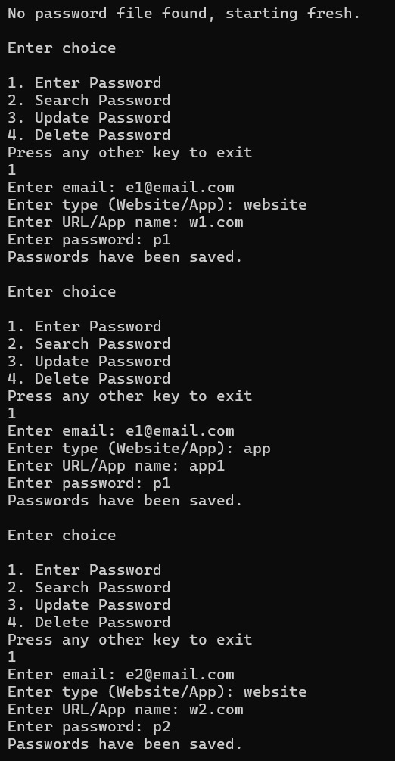

**B]** **Delete and update operations**

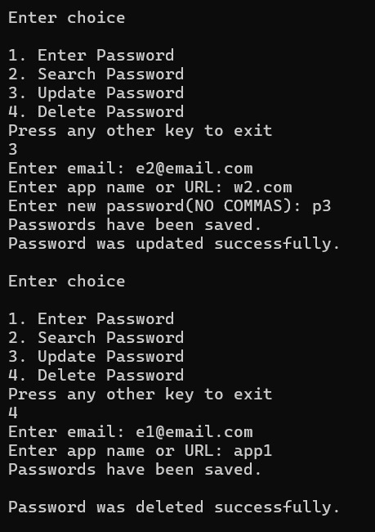

**C]** **Initial password file (after entering initial passwords)**

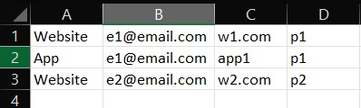

**D**] **Updated Password file (after updation and deletion)**

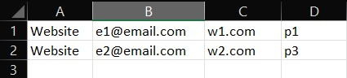

**GitHub Repository Link:**

<https://github.com/Sreenair-1/Password-Manager-Project->